CS 500 Module Seven Activity: Process Summary
Simple Calculator Program

Approach and Strategy
For this activity, I broke the calculator down into four stages: designing the logic with a flowchart, translating that logic into pseudocode, implementing it in Python, and testing it with unit tests. I started by mapping out the program's flow as a loop that repeatedly displays a menu, takes the user's choice and two numbers, performs the selected operation, and either returns to the menu or exits. I used the flowchart to identify the two key decision points: whether the user chose to exit, and whether a division by zero was being attempted, since that needed to be caught before the division ever ran.
Once the pseudocode reflected that logic, I wrote calculator.py using a while loop controlled by a boolean flag, with an if/elif chain to handle the four arithmetic operations and a guard clause that checks for a zero denominator before attempting division.
To support unit testing, I refactored the core arithmetic logic into a separate function, calculate(operation, num1, num2), that returns a result rather than printing it directly. This let me write assert-based tests that call the function with known inputs and check the output against expected values, without the tests getting stuck waiting on interactive input() calls.
How I Resolved Issues
My biggest obstacle was getting the tests to run correctly rather than the underlying arithmetic logic itself. When I first tried to import calculate from calculator.py, Python executed the entire file, including the interactive while loop, since the loop was not isolated inside a function. This meant importing the file for testing accidentally launched the live calculator menu instead of running my tests. I resolved this by moving the loop into a main() function and adding an if __name__ == "__main__": guard, which ensures the loop only runs when calculator.py is executed directly, not when it is imported.
Beyond that core issue, I ran into a chain of file-location problems while testing in VS Code that took several rounds of debugging to work through. The first error I encountered was a ModuleNotFoundError telling me Python could not find a module named calculator. I initially assumed this meant something was wrong with my code, but it turned out to be about where the terminal was pointed when it ran the command. The terminal prompt in VS Code showed I was standing at the root of my computer rather than inside my CS500 project folder, so Python had no way of finding calculator.py next to test_calculator.py. I fixed this by using the cd command to navigate into the correct folder before running the tests.
After fixing the folder location, I ran into a second error: PermissionError: Operation not permitted. This was not a Python problem at all, but a macOS privacy protection that blocks applications from accessing files on the Desktop unless they are explicitly granted permission. I resolved this by going into System Settings, then Privacy and Security, then Files and Folders, and enabling Full Disk Access for Visual Studio Code.
Even after fixing the permissions issue, I kept getting inconsistent results, sometimes ModuleNotFoundError and sometimes the calculator menu launching instead of my tests. Using the find command in the terminal, I discovered duplicate copies of both calculator.py and test_calculator.py sitting loose on my Desktop outside my CS500 folder, left over from earlier attempts. VS Code was sometimes running those stray copies instead of the correct ones inside CS500. I deleted the duplicates with the rm command so only the correct copies inside CS500 remained, which finally let the tests run consistently.
This experience taught me that debugging is not only about fixing logic errors in code. Several of the errors I hit had nothing to do with whether my Python was correct; they were about the environment the code was running in, including file paths, operating system permissions, and duplicate files.
Key Concepts Applied
This activity reinforced several core programming concepts from earlier in the course. I used a while loop rather than a for loop for the main menu, since the program does not know in advance how many calculations the user will want to perform; a while loop lets the program keep running based on a condition (a boolean flag named calculator) rather than a fixed number of repetitions.
I used an if/elif chain rather than separate if statements to check the user's menu choice, since elif ensures that once a match is found, Python skips the remaining checks rather than evaluating all four conditions on every pass.
I also applied type conversion, since input() always returns a string. The two numbers entered by the user needed to be converted to floats using float(input(...)) so they could be used in arithmetic.
Finally, I used a guard clause to catch the division-by-zero edge case before attempting the division, rather than letting Python raise a ZeroDivisionError. Checking num2 == 0 before performing num1 / num2 let the program respond gracefully instead of crashing.
Optimizing for Performance
One way I could optimize the code is to consolidate the duplicate zero-check logic, since the current version checks operation == "4" and num2 == 0 before the if/elif chain, and again inside the chain. Streamlining this into a single check inside the calculate() function would reduce redundancy and make the logic easier to maintain.
Unit Test Breakdown
Test 1 (Addition): calculate("1", 2, 3) checks that the function correctly adds two numbers, expecting a return value of 5.
Test 2 (Subtraction): calculate("2", 7, 2) checks that the function correctly subtracts the second number from the first, expecting a return value of 5.
Test 3 (Multiplication): calculate("3", 3, 2) checks that the function correctly multiplies two numbers, expecting a return value of 6.
Test 4 (Division): calculate("4", 25, 5) checks that the function correctly divides the first number by the second, expecting a return value of 5.
Test 5 (Division by zero, edge case): calculate("4", 5, 0) checks that the function correctly catches an attempt to divide by zero and returns the string "Answer is undefined" instead of raising a runtime error. This test matters because dividing by zero in Python normally raises a ZeroDivisionError, which would crash the program if left unhandled.
Full Program Listing (calculator.py)
SET calculator TO True
WHILE calculator is True
DISPLAY "1. Add 2. Subtract 3. Multiply 4. Divide 5. Exit"
INPUT choice
IF choice == 5 THEN
SET calculator TO False
INPUT num1
INPUT num2
IF choice == 4 AND num2 == 0 THEN
DISPLAY "Answer is undefined"
ELSE IF choice == 1 THEN
SET result TO num1 + num2
ELSE IF choice == 2 THEN
SET result TO num1 - num2
ELSE IF choice == 3 THEN
SET result TO num1 * num2
ELSE IF choice == 4 THEN
SET result TO num1 / num2
DISPLAY result

Unit Test Console Output
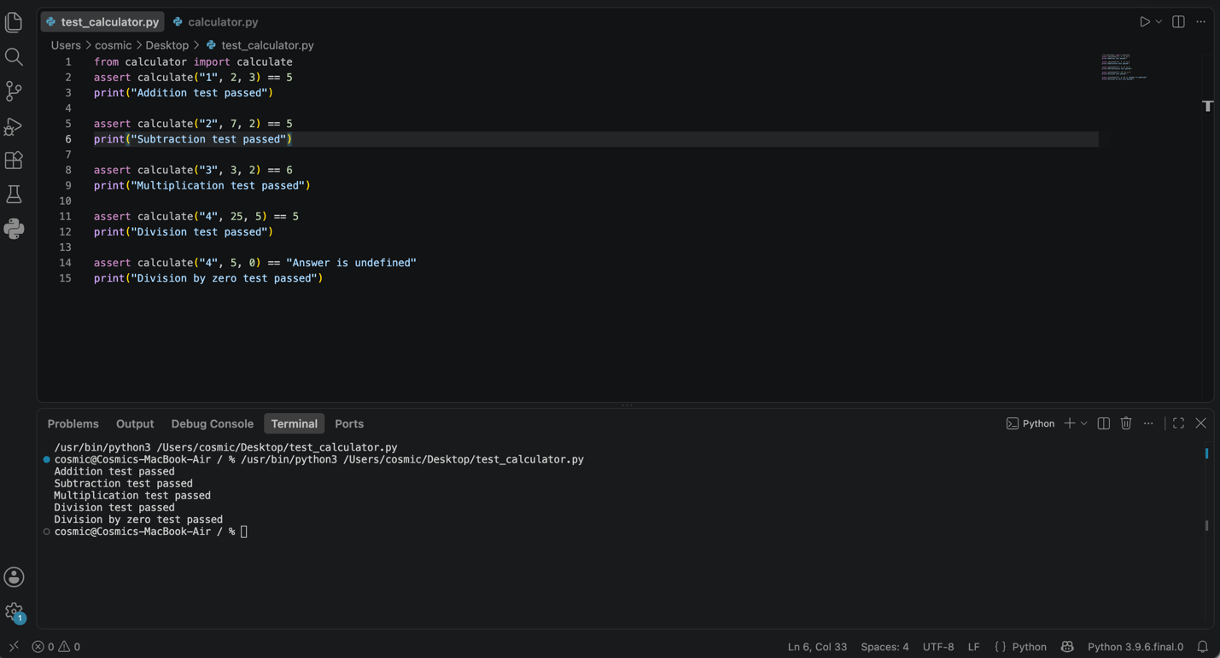
AI Usage Acknowledgment
I used Claude (Anthropic, 2026), a generative AI tool, to help organize this paper.

